
QUALITY ALERT

Customer: Windor Date: August 29, 2019
Die: 5254 / 5255 Colour: WH-136 / TAN-350
Type of Complaint: Windor REJECTED

Q.A # Q.I.R # CUSTOMER NCR #

Description: Windor REJECTED – Overall too small / shape is deformed and cannot weld

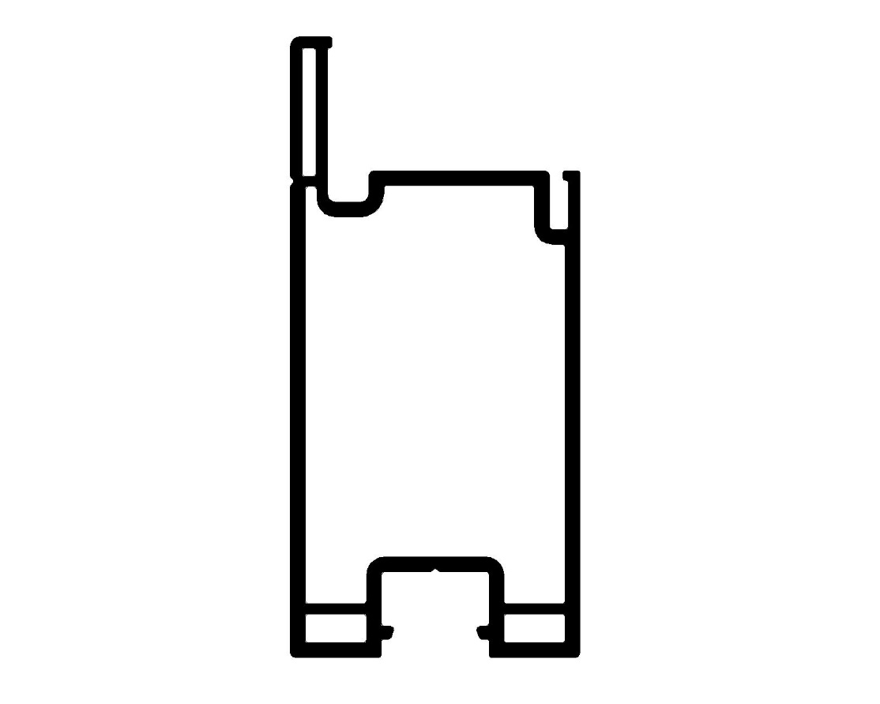
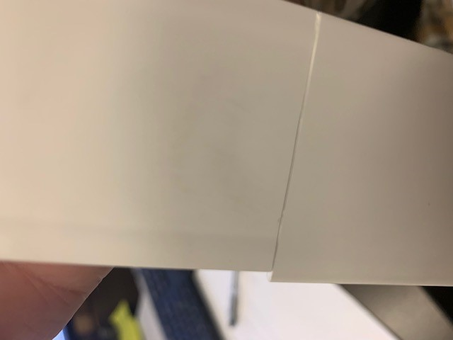
REJECTED SAMPLES – MUST CHECK BEFORE PACKING

3.750
2.940

2.940

BY SIGNING BELOW, YOU ACKNOWLEDGE THE PROBLEM ABOVE AND AGREE TO MONITOR THIS ISSUE IN FUTURE PRODUCTION RUNS.
DAY SHIFT |  | AFTERNOON SHIFT |  | NIGHT SHIFT
NAME | SIGNATURE | NAME | SIGNATURE | NAME | SIGNATURE

